Personal Training Client Health History Form
Please answer each question by printing the necessary information. Your answers will be kept confidential.
Client Information and Release Form
Name ___________________________________________ Birth Date _____________ Gender _________
Address ________________________________________________________________________________
City __________________________________________ State ________ Zip ________________________
Phone Number(s) Home___________________ Work __________________ Cell __________________
E-mail __________________________________________________________________________________
Employer _____________________________________ Occupation_________________________________ In case of emergency, please notify:
Name___________________________________________ Relationship ____________________________
Address ________________________________________________________________________________
City __________________________________________ State ________ Zip ________________________
Phone Number(s) ___________________ Home __________________ Work __________________ Cell
Please note: In order to assist you in the development of a rewarding physical fitness program, we need to have your honest and accurate responses.
General Medical History & Information
Are you under the care of a physician, chiropractor, or other health care professional for any reason?
If yes, list reason:__________________________________________________________________________________
Are you aware of any disease or disorder that would complicate your participation in a testing or exercise program?________________________________________________________________________________________
Has your doctor ever told you that you have a bone or joint problem that has been or could be made worse by exercise?______________________________________________________________________________________
Are you taking any medications? If yes please indicate the type of medication, dosage, frequency and reason(s) for taking it. _____________________________________________________________________________ Please list any allergies____________________________________________________________________________
Has your doctor ever said your blood pressure was too high? __________________________________________
Are you over age 65? _________________ Are you unaccustomed to vigorous exercise? ____________________
Is there any reason not mentioned here why you should not follow a regular exercise program?
If so, please explain ________________________________________________________________________________
Please describe any past or current musculoskeletal conditions you have incurred such as muscle pulls, sprains, fractures, surgery, back pain, or general discomfort:
Head / Neck _____________________________________________________________________________
Upper Back _____________________________________________________________________________
Shoulder / Clavicle _______________________________________________________________________
Arm / Elbow _____________________________________________________________________________
Wrist / Hand _____________________________________________________________________________ Lower Back _____________________________________________________________________________
Hip / Pelvis ______________________________________________________________________________
Thigh / Knee ____________________________________________________________________________
Lower Leg / Ankle / Foot
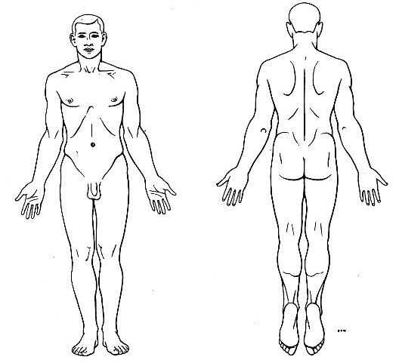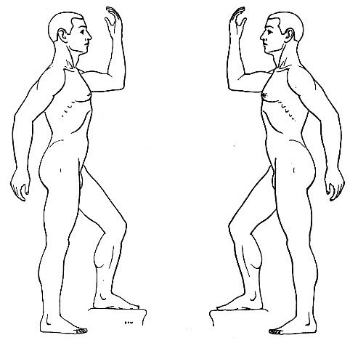
Please circle any areas of pain, injury, tension, or restriction of movement.
Have you recently experienced any chest pain associated with either exercise or stress?
If so, please explain ________________________________________________________________________________
Do you have a family history of any of the following conditions?
Heart Disease __________ Heart Attack __________ Hypertension __________ Gout __________
Abnormal EKG __________ Asthma __________ High Cholesterol __________ Angina __________

Diabetes __________ Other heart conditions __________
Do you have a family history of cardiovascular disease? If so, how many occurrences and what approximate ages? _______________________________________________________________________
Are you a smoker? If so, what is your smoking frequency? _____________________________________
Are you on any specific food / nutritional plan at this time? _____________________________________
Do you take dietary supplements? If yes, please list ___________________________________________

________________________________________________________________________________________
How many beverages do you consume per day that contains caffeine? ___________________________
Do you experience any frequent weight fluctuations? __________________________________________
Have you experienced a recent weight gain or loss? ___________________________________________

If yes, list change ___________________________________Over how long? _________________________
Your answers to these questions will be discussed with you prior to your session. Thank You.
Please take a moment to carefully read the following information and sign where indicated.
I understand that the personal training I receive is provided for the purpose of exercise instruction and guidance. I further understand that personal trainers are not qualified to perform, diagnose, prescribe, or treat any physical or mental illness, or provide nutritional planning, and that nothing said in the course of the session(s) given should be considered as such. I should see a physician, chiropractor, registered dietitian or other qualified medical specialist for any nutritional concerns, mental or physical ailment that I am aware of. I affirm that I have stated all my known medical conditions, and answered all questions honestly. I agree to keep the personal trainer updated as to any changes in my medical profile, and understand that there shall not be liability on the personal trainer’s part should I forget to do so. I understand that I have enrolled in the personalized health and fitness program offered by Larry Mahan Associates I recognize that the program may involve strenuous physical activity including, but not limited to, muscle strength and endurance training, cardiovascular conditioning and training, and other various fitness activities. I hereby affirm that I am in good physical condition and do not suffer from any know disability or condition which would prevent or limit my participation in this exercise program. I acknowledge that my enrollment and subsequent participation in purely voluntary and in no way mandated by Larry Mahan Associates and it’s personal trainers and affiliates. In consideration of my participation in this program, I hereby release Larry Mahan Associates and its personal trainers and affiliates from any claims, demands, and causes of action as a result of my voluntary participation and enrollment of the provided personal training services and/or exercise classes. I fully understand that I may injure myself as a result of my enrollment and subsequent participation in this program and I hereby release Larry Mahan Associates and it’s personal trainers and affiliates from any liability now or in the future for conditions that I may obtain. These conditions may include, but are not limited to, heart attacks, muscle strains, muscle pulls, muscle tears, broken bones, shin splints, heat prostration, injuries to knees, injuries to back, injuries to foot, or any other illness or soreness that I may incur, including death. I HEREBY AFFIRM THAT I HAVE READ AND FULLY UNDERSTAND THE ABOVE STATEMENTS.
Signature______________________________________________________ Date _____________________
Consent for minors is required prior to first session.
Signature of Guardian____________________________________________ Date _____________________
Printed name of Guardian __________________________________________________________________ Phone number the Guardian can be reached in case of emergency __________________________________
© 2009 Holistic Fitness & Massage LLC
Client Profile Questionnaire
Current Exercise Information
Please explain your current
exercise
regimen
including all strength training, cardiovascular training
or other sporting activities that you perform.
Day of the Week / Activity / Length of Time
Body Type / Activity Level / Goal
Information
What are your goals?
(
Circle
Those that apply)
Body Fat Loss Muscle Gain Strength Production Increase Flexibility General Health Maintenance
How active are you and/or what is your exercise lifestyle like? (Circle those that apply)
Sedentary Moderate Exercise Competitive Exercise Bodybuilding
Does your job require you to be….. (Circle those that apply)
Sedentary Somewhat Active Active Very Active Please answer yes or no to the following questions:
Is it hard for you to gain weight?
Can you eat a lot and still not gain weight?
Do you gain or lose weight according to your fluctuations in activity and food consumption?
Is it hard for you to lose weight?
Do you gain weight if you’re not careful about food intake?
Current Nutritional Consumption
Please list the foods, beverages, supplements etc that you take on the average day.
Time / Qty / Food-Beverage-Supplement
Food Likes / Dislikes / Restrictions
Please list the foods you prefer to eat.
Please list the foods you DO NOT prefer to eat.
Please list any foods that you must restrict for any reason i.e. medical etc.
Have you ever been told to follow a specific nutritional plan in the past? If so, please indicate the reason and the type of plan and who had provided it for you.
Please take a moment to carefully read the following information and sign where indicated.
I am purchasing the services of Larry Mahan Associates to design a program to aid in weight management to enhance my fitness goals. I will not hold Larry Mahan or any one working with Larry Mahan Associates and fitness couching personally liable for any problems, illnesses or injuries that might occur due to a sudden change in my eating or exercise habits. This program does not replace the advice of a medical doctor, registered dietitian or other medical provider or treatment. I have revealed any and all necessary information about myself to prevent any possible complications to Larry Mahan and Larry Mahan Associates Fitness and Couching.
Signature______________________________________________________ Date _____________________
2/09

